CSA1708-ARTIFICIAL INTELLIGENCE
LAB EXPERIMENTS
Program 25 : Prolog Program for Monkey Banana Problem
Aim
To use Prolog rules to plan how a monkey reaches and takes bananas.
Algorithm
1. Represent the monkey, box, and goal as a state.
2. Define the walk, push, climb, and grab actions.
3. Apply actions recursively until the monkey has bananas.
4. Query the planner to display the action sequence.
Program
banana_at(middle).
action(state(M,B,floor,no), walk, state(B,B,floor,no)) :-
M \= B.
action(state(P,P,floor,no), push, state(middle,middle,floor,no)) :-
banana_at(middle), P \= middle.
action(state(middle,middle,floor,no), climb, state(middle,middle,box,no)).
action(state(middle,middle,box,no), grab, state(middle,middle,box,yes)).
plan(state(_,_,_,yes), []).
plan(S,[A|Rest]) :- action(S,A,N),
plan(N,Rest).
solution(Plan) :- plan(state(door,window,floor,no), Plan).
Sample Input
?- solution(Plan).
?- banana_at(middle).
Program Execution
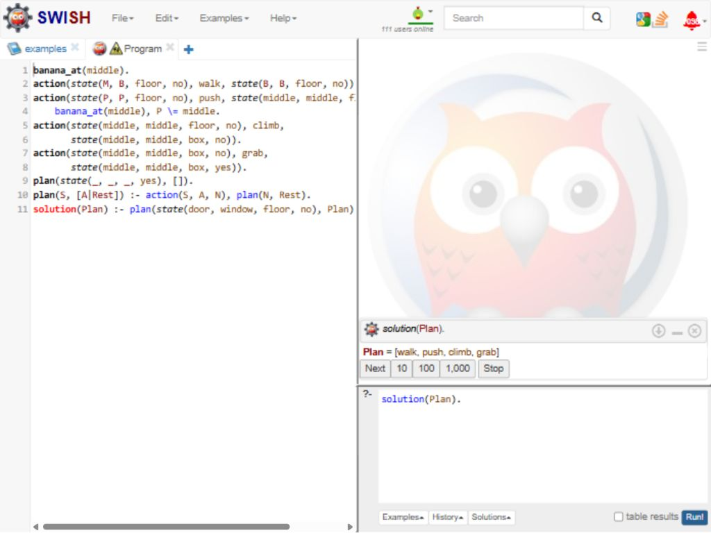
RESULT
Thus, Prolog generated an action plan and confirmed the banana location.

